## ***Cardholder responsibilities***

**The Cardholder MUST:**

* Only use the ***Traveler*** TCard for approved U of A business where a Travel Claim will be filed.
* Obtain required receipts, as these receipts must be attached to the Travel Claim.
* Ensure that Travel Claims are initiated within 15 days after return of trip. (***failure to comply may result in suspension or cancelation of your card)***
* Return the ***Traveler*** TCard to the Travel Office upon terminating employment or no longer using the TCard.
* If in doubt as to whether or not something can be purchased, please contact the Travel Office.
* Under **NO** circumstances should the ***Traveler*** TCard be used for personal expenses not related to valid business travel.
* **NEVER** allow another person to use your Traveler TCard. All charges download as a receivable against YOU, THE CARDHOLDER!

## ***REQUIRED RECEIPTS FOR TRAVELER tCARD PURCHASES***

* **Lodging**
* **Airfare**
* **Car Rental**
* **Registration**
* **Fuel for Car Rental**
* **Any Misc. Item (bag fee, parking, internet, etc)**
* **Valid Business Meal or Team Meal (itemized receipt)**

**Please Note: Unless you are a department which requires meal receipts, meal receipts are not required UNLESS a business meal or group meal for students and guests. (Receipt must be itemized)**

Always check with our department to insure whether or not the dept. will require receipts to be included when you file your travel claim. ***REGARDLESS OF WHETHER YOUR DEPT. REQUIRES INDIVIDUAL MEAL RECEIPTS, THESE RECEIPTS ARE NOT TO BE SENT TO THE TRAVEL OFFICE***

Meals are limited to 75% of the first and last day of travel up to the federal per diem rate for the area you are traveling.

===================================

**US BANK**

**Customer Service**

**1-800-344-5696**

**To activate your TCard you must call the 800 number displayed on the front of the card. You will then be asked to enter the card number and the last four digits of your SSN. You will also be asked to provide a contact phone number (number to call in case of suspected fraud) also provide the zip code of the billing address which is 72701**

TN00686_TN00686_TN00686_TN00686_

***Guide for Using***

***a***

***“Traveler” TCARD***

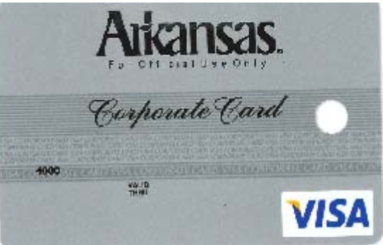

**Carol Wade: 479-575-7951**

**Donna Carter: 479-575-8414**

**Email:**

[**cawade@uark.edu**](mailto:cawade@uark.edu)

[**dcarter@uark.edu**](mailto:dcarter@uark.edu)

[**uatravel@uark.edu**](mailto:uatravel@uark.edu)

**Web Information:** [www.uark.edu/tcard](http://www.uark.edu/tcard)

## ***How Does the Traveler TCARD work?***

The ***Traveler*** TCard issued by US Bank and is a VISA credit card. It works similarly to your personal credit cards, except the charges are billed directly to the University and paid by the University Business Office.

Although the University pays the bill, all charges incurred will download as a **‘receivable’** against the cardholder. **In other words, you will be billed by the Treasurer’s Office for any charges not offset by the filing of your Travel Claim.**

These receivable charges will be stored in the U of A Accounts Receivable System. As Travel Claims are processed, the appropriate ***Traveler*** TCardCharges that coincide with the trip will be manually selected and associated with the Travel Claim. Any amounts not allowable to be reimbursed will be billed back by the Treasurer’s Office to the cardholder for repayment.

The U of A Accounts Receivable system will track the expenses incurred for each cardholder.

If a Travel Claim has not been processed to offset these charges within 15 days of return from trip, you will be notified. Failure to process the Travel Claim will result in suspension of your TCard and a payroll deduction will occur for repayment of the charges.

If a Traveler has more than two payroll deductions, the Traveler will lose the privilege of having a ***Traveler*** TCard.

Misuse of the card will subject Cardholder to disciplinary action in accordance with University Policies and Procedures relating to disciplinary action and termination for cause.

Although this card will be in an individual’s name, this is a U of A credit card; therefore this does not affect the individual’s personal credit history.

## ***Helpful Hints when using your Traveler TCARD***

* Have another form of payment just in case your ***Traveler*** TCard does not work. The State of Arkansas monitors the MCC codes assigned to a Merchant, and although every attempt has been made to open those MCC codes that the State and U of A felt would be used, there may still be instances when the MCC has been blocked.
* Ensure that whoever in the department is responsible for processing the Travel Claim does so within 15 days of return of trip and insure that when you review your travel claim that all charges you placed on your TCard have been selected and are displayed on your Travel Claim.
* You have the ability at any time of viewing your Traveler TCard Statement by logging into webBASIS and selected the ***My Travel*** link. From there you will then select the ***Traveler TCard Statement*** link.
* Take time to review your Travel Claim, prior to signing it to make sure that it is correct and that all charges from use of your ***Traveler TCard*** have been accounted for.

**In order for the Traveler TCard program to be successful, only allowable purchases are to be made with the TCard along with filing of Travel Claims within 15 days of return of trip in order to offset the charges incurred.**

## ***How will my TRAVELER TCard be audited?***

Not only will Legislative and system auditors audit ***Traveler*** TCards, but the Travel Office will also audit them. The following will be reviewed for compliance:

* Was a TA created for the traveler for whom the purchase was made?
* Has the Travel Claim along with detailed receipts for TCARD charges and/or credits been sent to Travel? (Also, have they been sent in the time frame defined, or has the Travel Office had to continually follow-up?)
* Are only charges related to a specific Travel Authorization being charged?
* Have the appropriate receipts been supplied for those charges where a receipt is required?

***Non-compliance with any of the above could result in your TCard privileges being revoked.***